**SmartBill Restaurant Management Point of Sale System**

The Project Proposal



University Of Vocational Technology

Faculty Of Information Technology

Group Project

Group No.05

IT204061 VISUAL PROGRAMMING I

IT206051 DATABASE SYSTEM & PROGRAMMING

2021-2022

|  |
| --- |
| **Learner declaration** |
| We,  S.M.C.M.Suraweera MMW/21/B1/32  T.P.G.R.Rangana SOF/21/B1/20  K.K.T.D.Jayathilaka NET/21/B1/36  W.A.L.K.Jayaweera SOF/21/B1/29  T.M.D.Minosha SOF/21/B1/13  certify that the work submitted for this assignment is my own and research sources are fully acknowledged. |

**Table of Content**

|  |  |  |
| --- | --- | --- |
|  | **Content** | **Page**  **Number** |
|  | Introduction  Objectives  Scope  Fact Finding Requirement  Proposed System  Requirement Analysis  Software Requirement  User Stories | **4-7** |
|  | System Diagrams  System ER Diagram  Usecase Diagram for Admin  Usecase Diagram for Customer  Usecase Diagram for Cashier | **8-10** |
|  | Questioners | **11-12** |
|  | Summary | **13** |

**Introduction**

The SmartBill Restaurant Management system is designed to help maintain orders and manage various aspects of a restaurant. The admin can handle category, item, reporting, analytics, and staff management. This restaurant management system is a WindowsForm (POS) project.

The main stakeholders are- **Admin, Cashier**

Employees are- **Cashier, Waiter, Chef**

Main Functions Are:

1. Category Management **(By Admin)**
2. Item Management **(By Admin)**
3. Reporting and Analytics **(By Admin)**
4. Staff Management **(By Admin)**
5. Order Management **(By cashier)**
6. Billing And Invoicing **(By cashier)**

**Objectives**

* To develop a Windows Form system that will help to manage the information about the coffees.
* It takes the suggestion from the user.
* This system is helpful for rural area people.
* It takes less processing time.
* To provide the fresh coffee and healthy product to the people

**Scope**

The SmartBill Restaurant Management System scope includes the end-to-end design, development, testing, and implementation of the Restaurant Management POS System. It will cover modules for category and item management, reporting and analytics, staff management, order processing, and billing. The system will be designed to run on standard hardware and integrate seamlessly with necessary peripherals

**Fact Finding Requirements**

1. What operations do you want to perform on the coffee shop Management?

* Update
* Delete
* Insert
* View

1. Did you want to link your website with social media?

* No

1. Did you need to take High security for your system?

* Yes

**Proposed System**

* This system is user friendly.
* It provides high security. It contains all operation like add, update, delete, view etc.
* It is an automated system.
* This system is helps to place order for Any Foods

**Requirement Analysis**

* Processor-AMD RYZEN 5 4600H
* Hard Disk-1 TB
* RAM- 16GB

**Software Requirement**

* Design Constraints
* Operating System-Windows 10 Home
* Frontend- Microsoft.NET Framework
* Backend- C#
* Database- SQL Server Management Studio

**User Stories**

**Category Management (By Admin):**

* Admins can efficiently organize items by creating, updating, and deleting menu categories to reflect changes in the restaurant's menu.

**Item Management (By Admin):**

* Admins have the ability to add, update, and remove menu items, ensuring accurate and relevant information in the restaurant's offerings.

**Reporting and Analytics (By Admin):**

* Admins can gain insights into restaurant performance by viewing daily sales reports and analyzing sales data by category and item.

**Staff Management (By Admin):**

* Admins can manage the staff effectively by adding, updating, and removing members, assigning roles as Cashier, Waiter, or Chef.

**Order Management (By Cashier):**

* Cashiers can efficiently handle customer orders, customizing them based on preferences and marking them as “Dine-in” or “Takeaway.’’

**Billing and Invoicing (By Cashier):**

* Cashiers can manage bills by splitting them among multiple customers, processing credit card payments with a 3% discount, and providing customizable receipts for customers, including an option to download as a PDF.

**System Design**

**System ER Diagram**

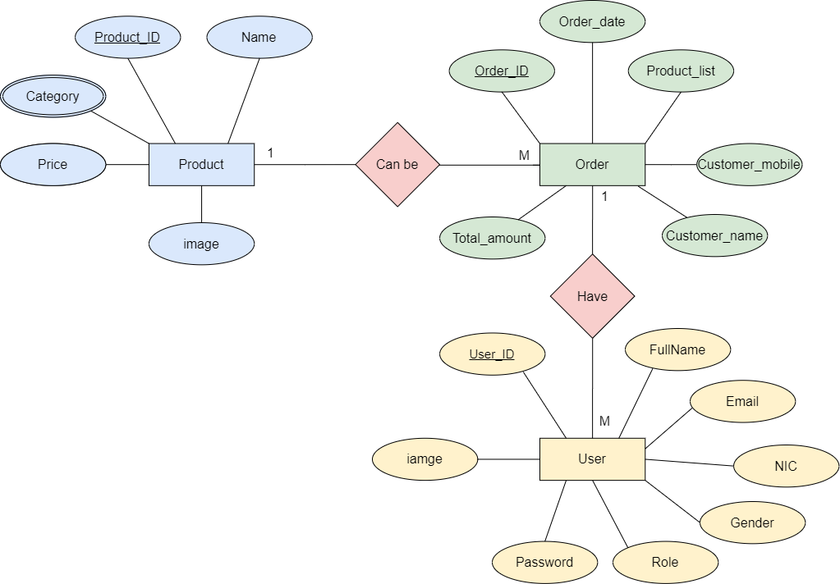

**UseCase Diagram for Admin**

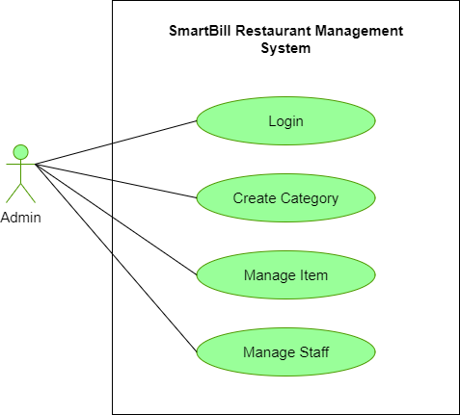

**UseCase Diagram for Customer**

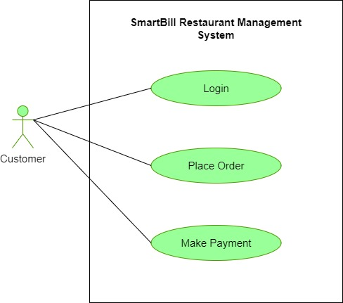

**Usecase Diagram for Cashier**

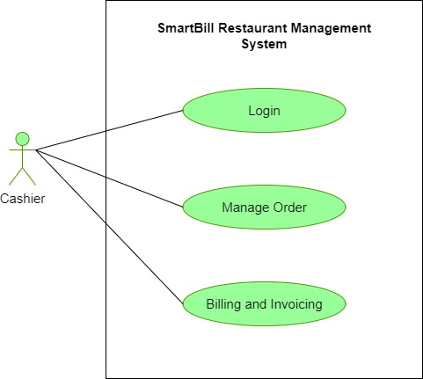

**Questioners**

**1. Stakeholder Feedback:**

**a. For Admins:**

* How satisfied are you with the ease of managing categories and items in the system?
* Do you find the reporting and analytics tools helpful in gaining insights into restaurant performance?
* Are the staff management features meeting your expectations in terms of efficiency?

**b. For Cashiers:**

* How comfortable are you with the order management system, particularly in customizing orders and handling different customer preferences?
* Is the billing and invoicing process straightforward, and are you able to provide a seamless customer experience?
* Are there any additional features you would like to see in the system to improve your workflow?

**2. User Experience:**

**a. For Admins and Cashiers:**

* How intuitive do you find the user interface of the system?
* Are there any challenges or difficulties you encounter while using the system?
* What additional features or improvements would enhance your overall experience?

**3. System Performance:**

**a. For IT Support:**

* Have there been any instances of system slowdowns or performance issues?
* How responsive is the system to simultaneous user interactions, especially during peak hours?

**4. Security Assessment:**

**a. For IT Security Team:**

* Have there been any security incidents or breaches since the implementation of the system?
* How confident are you in the implemented security measures to protect sensitive data?

**Summary**

The SmartBill Restaurant Management System is a robust WindowsForm (POS) project designed for efficient coffee shop management, featuring modules for category and item organization, reporting, staff management, order processing, and billing. Tailored for administrators and cashiers, the user-friendly system prioritizes security, rural accessibility, and quick processing times. Technical specifications include an AMD RYZEN 5 4600H processor, 1 TB hard disk, and 16GB RAM, running on Windows 10 Home with Microsoft.NET Framework, C#, and SQL Server Management Studio. The project scope encompasses end-to-end design, development, testing, and implementation, with appendices detailing data and entity flow, system architecture, user interface mockups, database schema, and security measures. Stakeholder feedback and questionnaires on user experience, system performance, and security assessment contribute to ongoing improvements, ensuring the SmartBill system provides fresh, healthy products and a seamless restaurant management experience.